**TUGAS 01**

**APLIKASI FLUTTER**



Praktikum Pemrograman Berbasis Web - A

Nama :

Adelia Nurlina Putri 4521210059

**PROGRAM STUDI S1 TEKNIK INFORMATIKA**

**FAKULTAS TEKNIK**

**UNIVERSITAS PANCASILA**

**JAKARTA**

**2024**

1. **Instalasi Flutter SDK**
2. Akses web <https://docs.flutter.dev/get-started/install>
3. Pilih OS yang digunakan untuk penggunaan Flutter : macOS

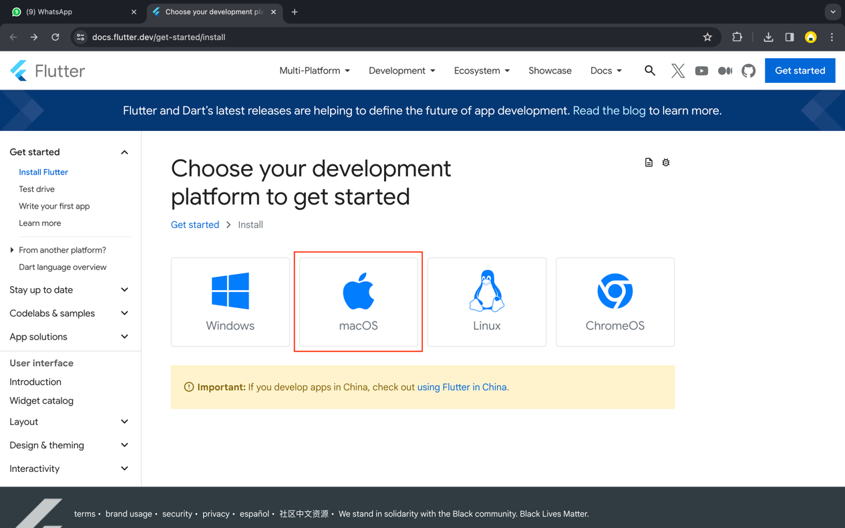

1. Pilih tipe App : Android

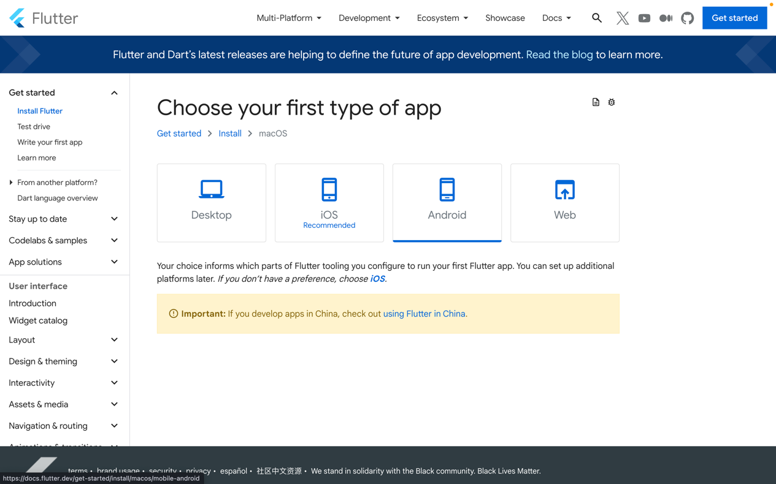

1. Cek default shell (Flutter support MacOS Catalina default shell menggunakan zsh)

|  |
| --- |
| dscl . -read ~/ UserShell |

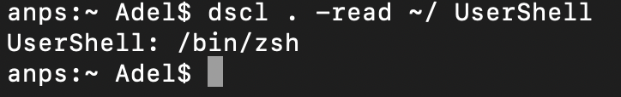

1. Beberapa komponen Flutter memerlukan proses Rosetta 2 di Mac Apple Silicon. Untuk menjalankan semua komponen Flutter di Apple Sillicon, maka perlu instal Rosetta 2.

|  |
| --- |
| sudo softwareupdate --install-rosetta --agree-to-license |

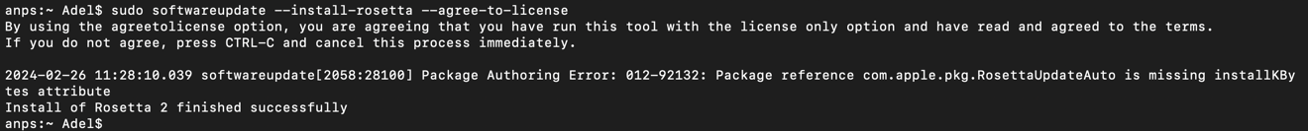

1. Download & Install Visual Studio Code (Installed)
2. Install Flutter Extension

|  |
| --- |
| Buka VSCode -> Marketplace -> Ketik Flutter -> Install |

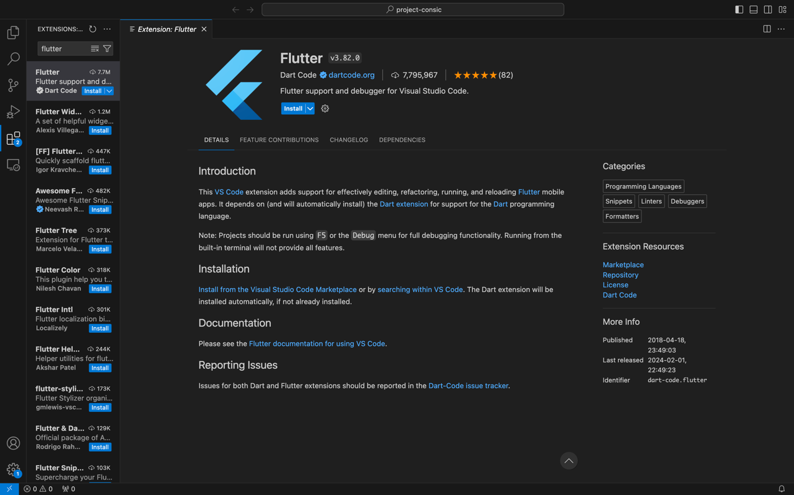

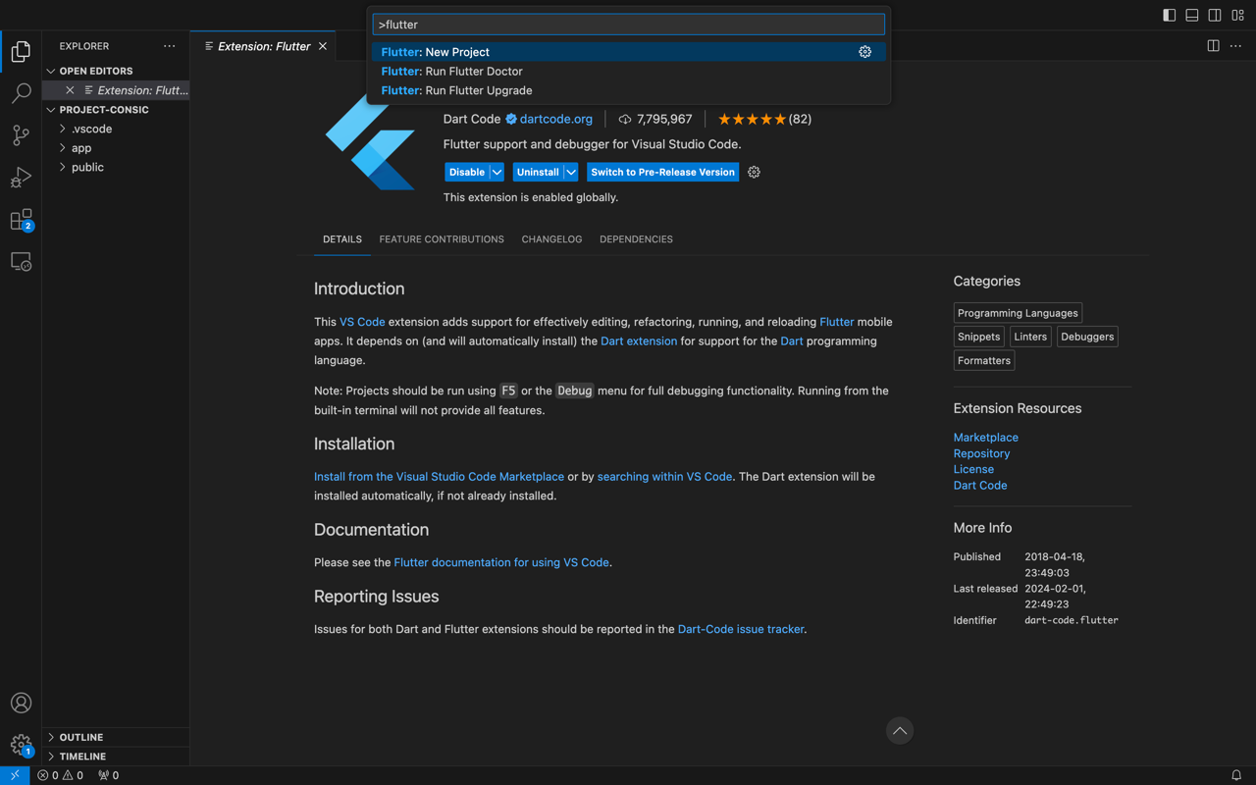

1. Install Flutter SDK

|  |
| --- |
| Buka VSCode -> Command+Shift+P -> Ketik Flutter -> Pilih Flutter: New Project |

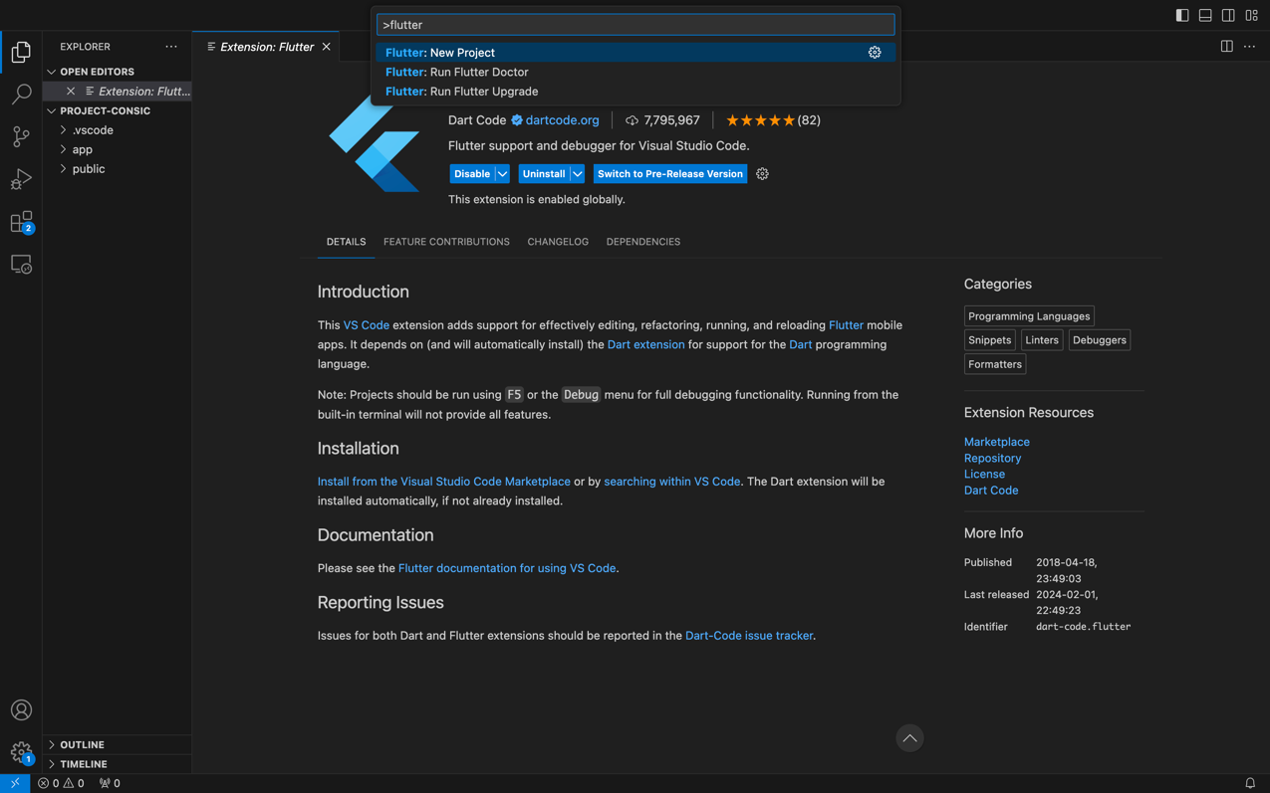

1. Pilih Download SDK

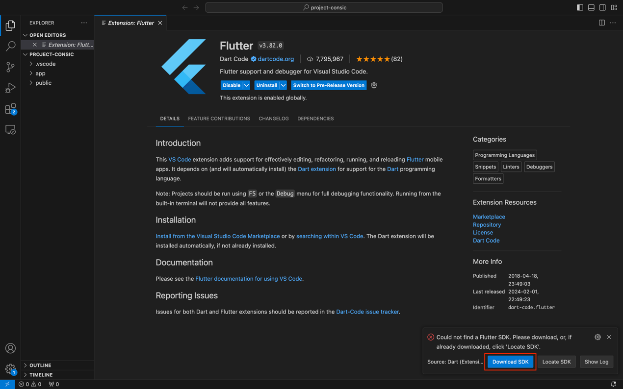

1. Pilih tempat untuk menyimpan file SDK

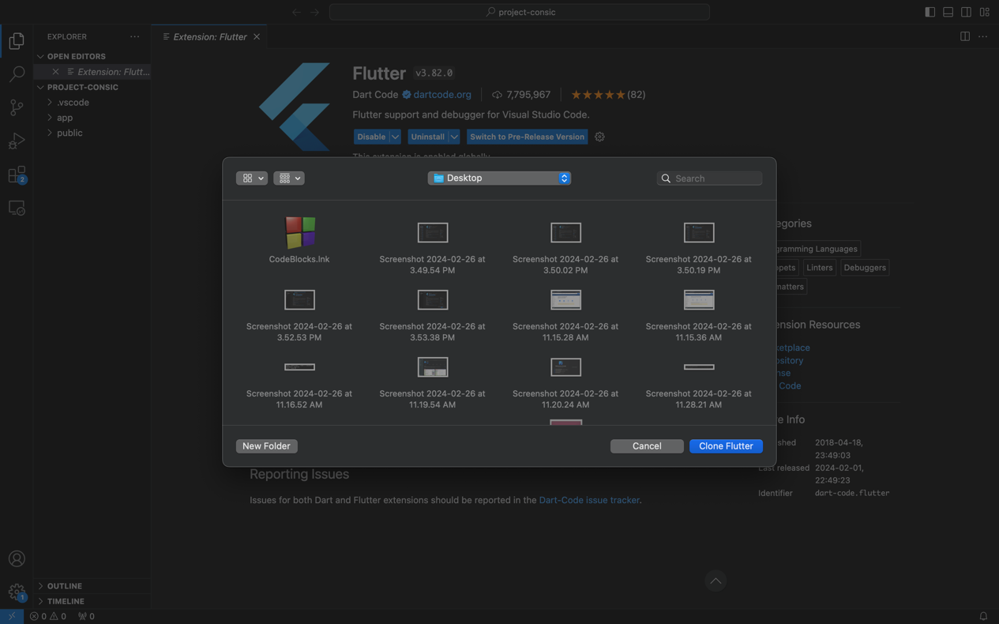

1. Downloading dan Initializing proses

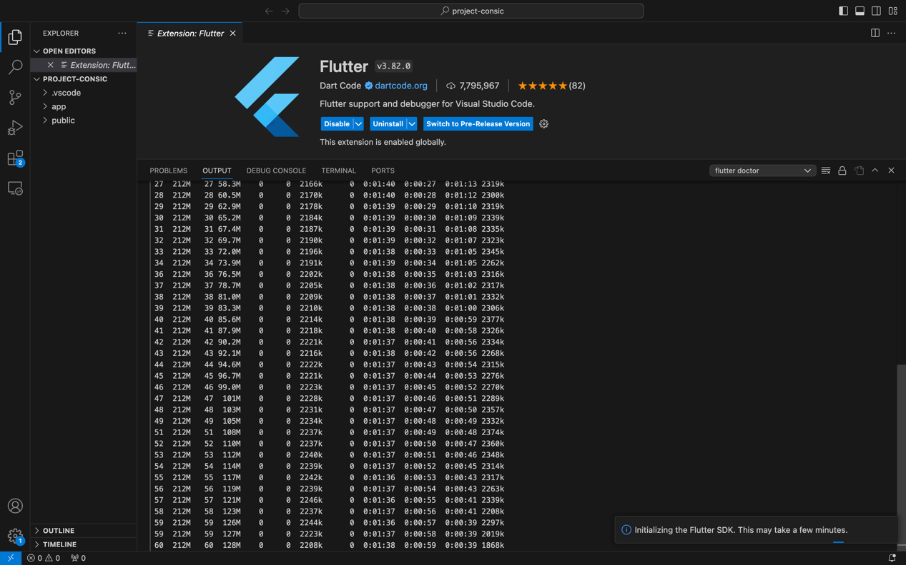

1. Mengaktifkan Flutter pada seluruh terminal

|  |
| --- |
| sudo nano ~/.zshrc  ---  export PATH="$PATH:/Users/Adel/Desktop/flutter/bin"  ---  echo $ PATH |



1. **Validasi Komponen Flutter**

|  |
| --- |
| $ flutter doctor |

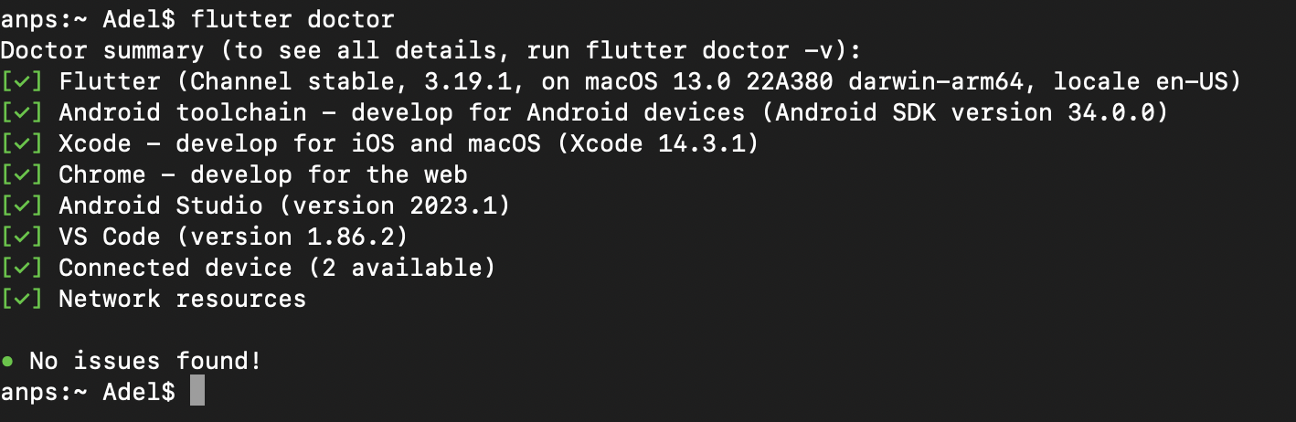

1. **Membuat Project Flutter**
2. **Referensi**

* <https://docs.flutter.dev/get-started/install/macos/mobile-android?tab=virtual>
* <https://marketplace.visualstudio.com/items?itemName=Dart-Code.flutter>
* <https://docs.flutter.dev/get-started/install/macos/mobile-android?tab=virtual>
* <https://docs.flutter.dev/get-started/install/macos/mobile-ios>
* <https://www.codewithhussain.com/flutter-cmdline-tools-component-is-missing>
* <https://codelabs.developers.google.com/codelabs/flutter-codelab-first?hl=id#0>